# PROJ3 Admin Panel

## 11. Test application over HTTPS connection, (screenshot evidence)

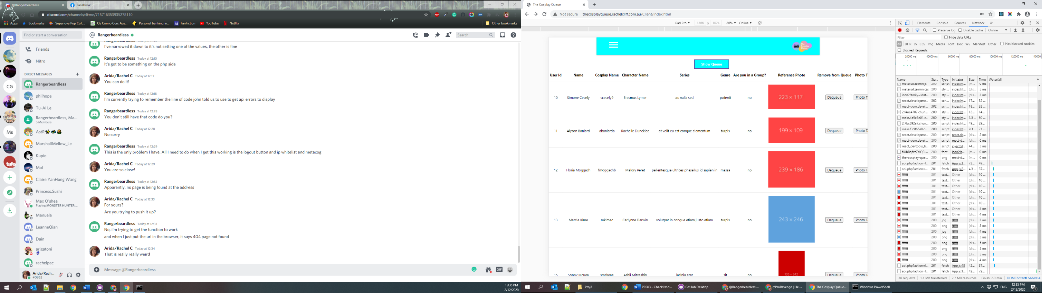Admin Panel URL is <http://thecosplayqueue.rachelcliff.com.au/Client/index.html> SSL still hasn’t loaded successfully but it is up online and functioning. The frontend can be found here: <https://xavrom.com/Client/index.html>

## PART D - Metacognition

## 12. Comment on each of the 3rd party frameworks used, why was it chosen

For this admin panel I have chosen 2 primary 3rd party frameworks to construct the final solution. These frameworks consist of Materialize which was the base framework for the frontend of my app, React as it is the most requested framework that I have seen in current job advertisements. React was also used as my form validation framework as it made sense to do the JSX validation natively, and not introduce another third party dependency into the code which could become a liability in the future.

## 13. What other technologies did you investigate in order to settle on a path?

As part of my research into the admin panel I also investigated the technology of Vue. The decision to choose React was due to the reason that out of the all the job listings that I have looked at over the past year React was the highest requested framework technology, with Vue coming in a close second.

## 14. Describe the rules by which your authentication restricts access. Comment in code.

In order to restrict access to the admin panel I have utilised two different forms of validation. IP whitelisting and the addition of admin credentials to the database. For IP whitelisting I have set a rule in place that states that if a user isn’t accessing the page from the IP address of 117.20.64.153 which is the IP of my home localhost it will hide all elements on the page and display a message saying that the user doesn’t have the permission to be on the page and direct them back to the homepage.

The introduction of admin credentials to the admin panel adds an extra criterion (the user must be admin) in order to log onto the admin panel page. Anyone who does successfully access the page via the same IP address but doesn’t have the correct admin credentials will not be able to log onto the admin panel and it will return an error.

## 15. Describe why you chose this particular encryption

When it comes to password encryption, I elected to use the default php encryption as it is easy to use and incredibly stable when it comes to functionality. I have also implemented this form of encryption into the frontend of my app and it made sense to keep form of encryption and hashing consistent across the app.